9oiuyhjkl
Year 9 Mathematics Curriculum Medium-Term Plan HT2

.

The most important purpose of curriculum planning documents is that they will specify everything that students should learn. What is not specified is far less likely to be taught, let alone assessed appropriately.

Term | Half Term | Year 9 Overview
Autumn | HT1 | LO1: Place Value  LO2: Ordering decimals & Integers.  LO3: Calculations with negative numbers.  LO4: BIDMAS  LO5: Powers & Roots & Primes and proof  LO6: Standard Form
 | HT2 | LO1: Algebraic expressions.  LO2: Solving Equations  LO3: Writing formulas  LO4: Position to term rule.
Spring | HT3 | LO1: Equivalent fractions  LO2: Adding and subtracting Fractions  L03: Mixed numbers & Improper fractions.  LO4: Multiplying whole numbers by fractions.  LO5: Simplifying Ratio.  LO6: Percentage Change.
 | HT4 | LO1: Properties of triangles & Quadrilaterals.  LO2: Deduction  LO3: Rotation and Translation  LO4: Vectors
Summer | HT5 | LO1: Probability Scale.  LO2: Sample space diagram.  LO3: Venn Diagrams.  LO4: Transformations.  LO5: Three dimensional shape.  LO6: Pythagoras
 | HT 6 | LO1: Scatter graphs & Correlation.  LO2: Lines of best fit  LO3: Mean, median, mode & Ranges.  LO4: Ungrouped& Grouped frequency tables.  LO5: Pictograms & Bar Charts.  LO6: Construction

Term & Year Group | Autumn Term 2
Links to the National Curriculum/Examination Specification | Select and use appropriate calculation strategies to solve increasingly complex problems;  Use algebra to generalise the structure of arithmetic, including to formulate mathematical relationships;  Substitute values in expressions, rearrange and simplify expressions, and solve equations;  Move freely between different numerical, algebraic, graphical and diagrammatic representations [for example, equivalent fractions, fractions and decimals, and equations and graphs];  Develop algebraic and graphical fluency, including understanding linear and simple quadratic functions;  Use language and properties precisely to analyse numbers, algebraic expressions, 2-D and 3-D shapes, probability and statistics;  Extend their understanding of the number system; make connections between number relationships, and their algebraic and graphical representations;  Identify variables and express relations between variables algebraically and graphically; Make and test conjectures about patterns and relationships; look for proofs or counter- examples;  Begin to reason deductively in geometry, number and algebra, including using geometrical constructions;  Use and interpret algebraic notation, including  - ab in place of a × b  - 3y in place of y + y + y and 3 × y  - a² in place of a × a, a³ in place of a × a × a; a²b in place of a × a × b  - ª in place of a  b  - coefficients written as fractions rather than as decimals  - brackets;  Substitute numerical values into formulae and expressions, including scientific formulae;  Understand and use the concepts and vocabulary of expressions, equations, inequalities, terms and factors;  Simplify and manipulate algebraic expressions to maintain equivalence by:  - collecting like terms  - multiplying a single term over a bracket  - taking out common factors  - expanding products of two or more binomials;  Understand and use standard mathematical formulae; rearrange formulae to change the subject;  Model situations or procedures by translating them into algebraic expressions or formulae and by using graphs;  Use algebraic methods to solve linear equations in one variable (including all forms that require rearrangement);  Interpret mathematical relationships both algebraically and graphically;  Recognise, sketch and produce graphs of linear and quadratic functions of one variable with appropriate scaling, using equations in x and y and the Cartesian plane;  Reduce a given linear equation in two variables to the standard form y = mx + c; calculate and interpret gradients and intercepts of graphs of such linear equations numerically, graphically and algebraically;  Use linear and quadratic graphs to estimate values of y for given values of x and vice versa and to find approximate solutions of simultaneous linear equations;  Find approximate solutions to contextual problems from given graphs of a variety of functions, including piece-wise linear, exponential and reciprocal graphs;  Generate terms of a sequence from either a term-to-term or a position-to-term rule,  Recognise arithmetic sequences and find the nth term; Recognise geometric sequences and appreciate other sequences that arise  Develop their mathematical knowledge, in part through solving problems and evaluating the outcomes, including multi-step problems;  Develop their use of formal mathematical knowledge to interpret and solve problems, including in financial mathematics;  Begin to model situations mathematically and express the results using a range of formal mathematical representations;  Select appropriate concepts, methods and techniques to apply to unfamiliar and non- routine problems.
Overall Aims | What are the overarching aims for students in terms of the key substantive knowledge components, disciplinary knowledge (skills) and understanding they will develop?  By the end of this unit students should understand some basic algebraic conventions and that algebra is a way of generalising. The main knowledge is:  Understanding algebraic conventions eg., 2a means 2 x a etc  Simplifying algebraic expressions involving addition and subtraction  Understanding algebraic conventions for multiplication and division including powers  Simplifying algebraic expressions involving multiplication/division  Multiplying a single digit over a bracket  Multiplying a single digit over a bracket and then collecting like terms  Multiplying double brackets and collecting like terms  Factorising where the common factor is a single digit  Solving linear equations using inverses  Solving linear equations using inverses (including where bracket expansion is necessary first)  Solving linear equations with variables on both sides  Write formulas from a problem, substitute values into formulas to find answers  Rearrange formulas to make another letter the subject.  By the end of this unit students should be able to identify patterns and generalise these mathematically. The main knowledge is:  Finding position to term rules  Writing position to term rules algebraically  Using position to term rules to predict the nth term  Forming 1 and 2 step linear equations to solve linear sequences;  Substituting into linear sequences to find the nth term  Generalising the formula for arithmetic sequences
Prior learning & common misconceptions | What learning has come before this unit that should be drawn upon to secure deeper understanding and make connections?  Students will benefit from visual sequences and patterns initially as well as physical sequences eg., match sticks, counters.  Students will have seen algebraic puzzles before using pictures rather than variables and these are a good starting point.  Link rules with number to rules with algebra.  It is important that teachers assess retention before starting the topic so that they can build on prior learning.  Students will have been exposed to sequences as function machines and these are a useful starting point and support for individuals where necessary.  With index laws it is important to teach it with understanding rather than just a rule – link it into prior knowledge of cancellation of terms.  Be explicit that equations and formulas are really the same things with different names.  What are the common misconceptions that hinder progress?  Avoid using a for apples and b for bananas in your vocabulary so that students understand a ≠ 1 apple. Use ‘the number of’ in your language eg a = a number of apples.  Students confuse x² with 2x  Students confuse √x with x÷2 etc  Be specific with mathematical algebraic conventions eg 2t means 2 x t  Be specific with language such as the difference between an expression and an equation.  Be specific with equations, formulas, formulae, functions are all really the same thing  Clarify that BODMAS/BIDMAS is a mathematical convention so that we don’t get different answers  ‘Simplify’ in English suggests the answer looks simpler whereas in maths ‘simplify’ means re-write and the answer often doesn’t look simpler  Clarify that sometimes in maths we only ask for something to be simplified, rather than solved. This means the answer will still have variables in it.  Check calculator does BODMAS/BIDMAS or students will need to use brackets on calculators  With index laws it is important to teach it with understanding rather than just a rule – link it into prior knowledge of cancellation of terms.
Assessment | How will student progress be assessed through both formative & summative assessments?  Lesson by Lesson  Use of mini-whiteboards  Low stakes quizzes for connect activities to embed prior learning – especially with mathematical terminology  Daily opportunities for retrieval practice in recall activity at beginning of lesson  Pupils will be regularly assessed through classwork, features of this include routine starter tasks that allow a revisit to previously taught aspects of the curriculum to improve recall;  Progress Checks  Low stake quizzes eg Bingo  Skillful Q&A by teachers is a regular feature of maths lessons to assess understanding, inform activities, and identify any misconceptions.  Individual feedback provided to students identifying next steps  End of Topic  Half termly assessments, with QLA produced (not yet at KS3), used formatively to inform recall tasks  Individual feedback provided to students identifying next steps
Language & Reading | What is the provision to…  Talk like a specialist  - Students will be introduced to key terminology and be challenged to use this at every opportunity  Write like a specialist.  - Include reason and examples in answers and write algebraically and graphically  Read like a specialist  - Given a written problem, interpret and use information to navigate an efficient pathway that results in an accurate solution  - Read and interpret mathematics written algebraically or graphically
Links to SMSC/SRE/British Values | Spiritual Education  - We strive to enable each of our students to use their imagination and creativity to explore ideas while learning mathematics by: identifying and applying patterns and rules to everyday problem-solving;  - Writing their own problems and challenges that use those patterns or rules.  Moral Education  - Broadening the pupils' understanding of the consequences of actions: Eg. If you perform a particular action to one number, will the same outcome apply to other numbers? Is it always the case? ‘Sometimes, always, never’ statements will be explored and addressed.  Social Education Developing personal qualities and using social skills:  - Working in pairs or groups to solve problems; Perseverance when struggling to answer questions; not being afraid to try – it’s ok to be wrong, it’s not ok not to try; taking turns when playing maths games. Participating, co-operating and resolving conflicts: as above, but also ‘X thinks ___, Y thinks ___, who is right?’ type questions.  Cultural Education  - Understanding and appreciating personal influences: taking into account other people’s views and understanding how to express own views. Eg. How to explain to someone where they may have gone wrong in a question.  British Values  Democracy  - Take into account the views of others in shared activities. Voting when collecting data.  The Rule of Law  - Undertake safe practices, following class rules during tasks and activities for the benefit of all. Understand the consequences if rules are not followed.  Individual Liberty  - Work within boundaries to make safe choices during practical activities. Make your own choices within data handling activities.  Tolerance of those with different faiths and beliefs  - Use maths to learn about different faiths and cultures around the world. Eg. looking at patterns/shapes within Islam / Hindu religions.  Mutual Respect  - To behave appropriately, allowing all participants the opportunity to work effectively. Take turns and share equipment. Review each other’s work respectfully. Work collaboratively on projects/problems, help and advise others

Knowledge Components at a Glance

Composite Performance: Algebraic Thinking

Algebra
Sequences
I know how to expand and factorise single and double brackets.
I know mathematical conventions for solving equations containing fractions, brackets and variables on both sides.

Formulas
I know how to find a position to term rule (nth term) to find terms and positions in a sequence.
I know how to find the nth term rule for a sequence.

I can expand and factorise single and double brackets.
I can solve equations containing fractions, brackets and variables on both sides.

I can use a position to term rule (nth term) to find terms and positions in a sequence.
I can find the nth term rule for a sequence.

I can form formulas, substitute values into formulas and rearrange formulas to make another letter the subject.

I can read a worded question and from it form a mathematical equation.

Week/ Lesson  Key Question? | Key knowledge components & Lesson Outcomes  What do students need to know & what should they be able to do? | Pedagogy & Assessment– How do we teach and assess this at Coal Clough Academy? Strategies to support students knowing more & remembering more  Suggested teaching activities & resources including ‘non-negotiables’ for delivery e.g. minimum of two assessment style questions per week, minimum of one practical per week…
Week 1/ Lesson 1 | What are the key knowledge components students must be taught this lesson?  - This lesson is a pre-cursor to “I know how to expand and factorise single and double brackets”  What are the learning outcomes for this lesson?  - Understanding algebraic conventions eg., 2a means 2 x a etc  - Simplifying algebraic expressions involving addition and subtraction  Key Questions:  What does 3a mean? Is it 3+ a, 3-a or what?  Can I collect 3a with 4a?  Can I collect 3a with 3a²? Why not?  What about 3a and 3ab – do we collect them together? | Key vocabulary for this lesson & how it will be introduced?  Pattern, generalise, predict, substitute, inverse, term, cancelling out/cancelling down  Recall activity: 4 Qs (last lesson, last week, last month, last topic); Use questions from assessments (informal and formal) and QLA.  Suggested teaching activities, pedagogy and assessment to inform next steps:  Avoid using a for apples and b for bananas in your vocabulary so that students understand a ≠ 1 apple. Use ‘the number of’ in your language eg a = a number of apples.  Students confuse x² with 2x  Be specific with mathematical algebraic conventions eg 2t means 2 x t  Be specific with language such as the difference between an expression and an equation  Link rules with number into rules with algebra eg $\frac{10}{5}$ cancels to 2, $\frac{10 x y x y}{5 x y}$ cancels to 2y etc
Addressing gaps  SEND learners have a Pupil Passport that informs strategies for learning bespoke to that student.  Staff must make sure they are familiar with the various strategies involved and embed these in their lessons. |  | Deepening knowledge  Use examples with lots of negatives to recap directed number – remind students that rules for algebra are the same as rules for number.  Use examples where BODMAS/BIDMAS is involved so that students extend their knowledge of number

Week/ Lesson  Key Question? | Key knowledge components & Lesson Outcomes  What do students need to know & what should they be able to do? | Pedagogy & Assessment– How do we teach and assess this at Coal Clough Academy? Strategies to support students knowing more & remembering more  Suggested teaching activities & resources including ‘non-negotiables’ for delivery e.g. minimum of two assessment style questions per week, minimum of one practical per week…
Week 1/ Lesson 2 | What are the key knowledge components students must be taught this lesson?  - This lesson is a pre-cursor to “I know how to expand and factorise single and double brackets”  What are the learning outcomes for this lesson?  - Understanding algebraic conventions for multiplication and division including powers  - Simplifying algebraic expressions involving multiplication/division  Key Questions:  What is $\frac{10}{5}$ equal to?  What is $\frac{10 x y x y}{5 x y}$ equal to?  Can you simplify it further? Are there any ‘like terms’ that you can collect together?  Can you collect 2y with 2yz? Why not?  Can you collect 2y with 2y² ? Why not? | Key vocabulary for this lesson & how it will be introduced?  Pattern, generalise, predict, substitute, inverse, term, cancelling out/cancelling down  Recall activity: 4 Qs (last lesson, last week, last month, last topic); Use questions from assessments (informal and formal) and QLA.  Suggested teaching activities, pedagogy and assessment to inform next steps:  Avoid using a for apples and b for bananas in your vocabulary so that students understand a ≠ 1 apple. Use ‘the number of’ in your language eg a = a number of apples.  Students confuse x² with 2x  Be specific with mathematical algebraic conventions eg 2t means 2 x t  Be specific with language such as the difference between an expression and an equation  Link rules with number into rules with algebra eg $\frac{10}{5}$ cancels to 2, $\frac{10 x y x y}{5 x y}$ cancels to 2y etc
Addressing gaps  SEND learners have a Pupil Passport that informs strategies for learning bespoke to that student.  Staff must make sure they are familiar with the various strategies involved and embed these in their lessons.  Students need to understand why we can cancel down eg see key questions above |  | Deepening knowledge  Use equations with fractions, decimals and negatives  Use some questions where students have to apply BODMAS/BIDMAS

Week/ Lesson  Key Question? | Key knowledge components & Lesson Outcomes  What do students need to know & what should they be able to do? | Pedagogy & Assessment– How do we teach and assess this at Coal Clough Academy? Strategies to support students knowing more & remembering more  Suggested teaching activities & resources including ‘non-negotiables’ for delivery e.g. minimum of two assessment style questions per week, minimum of one practical per week…
Week 1/ Lesson 3 | What are the key knowledge components students must be taught this lesson?  - This lesson is a pre-cursor to “I know how to expand and factorise single and double brackets”  What are the learning outcomes for this lesson?  - Understanding algebraic conventions for multiplication and division including powers  Key Questions:  What is $\frac{10}{5}$ equal to?  What is $\frac{10 x y x y}{5 x y}$ equal to?  Can you simplify it further? Are there any ‘like terms’ that you can collect together?  Can you collect 2y with 2yz? Why not?  Can you collect 2y with 2y² ? Why not? | Key vocabulary for this lesson & how it will be introduced ?  Pattern, generalise, predict, substitute, inverse, term, cancelling out/cancelling down, index, indices, powers  Recall activity: 4 Qs (last lesson, last week, last month, last topic); Use questions from assessments (informal and formal) and QLA.  Suggested teaching activities, pedagogy and assessment to inform next steps:  Avoid using a for apples and b for bananas in your vocabulary so that students understand a ≠ 1 apple. Use ‘the number of’ in your language eg a = a number of apples.  Students confuse x² with 2x  Be specific with mathematical algebraic conventions eg 2t means 2 x t  Be specific with language such as the difference between an expression and an equation  Link rules with number into rules with algebra eg $\frac{10}{5}$ cancels to 2, $\frac{10 x y x y}{5 x y}$ cancels to 2y etc  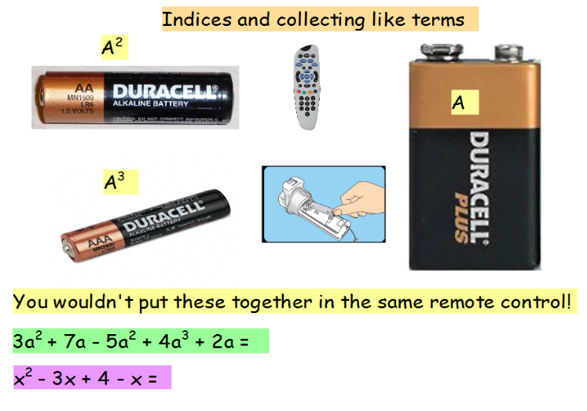
Addressing gaps  SEND learners have a Pupil Passport that informs strategies for learning bespoke to that student.  Staff must make sure they are familiar with the various strategies involved and embed these in their lessons.  Students need to understand why we can cancel down eg see key questions above |  | Deepening knowledge  Use equations with fractions, decimals and negatives  Use some questions where students have to apply BODMAS/BIDMAS

Week/ Lesson  Key Question? | Key knowledge components & Lesson Outcomes  What do students need to know & what should they be able to do? | Pedagogy & Assessment– How do we teach and assess this at Coal Clough Academy? Strategies to support students knowing more & remembering more  Suggested teaching activities & resources including ‘non-negotiables’ for delivery e.g. minimum of two assessment style questions per week, minimum of one practical per week…
Week 2/ Lesson 4 | What are the key knowledge components students must be taught this lesson?  - I know how to expand and factorise single and double brackets  - I can expand and factorise single and double brackets  What are the learning outcomes for this lesson?  - Multiplying a single digit over a bracket  - Multiplying a single digit over a bracket and then collecting like terms  Key Questions:  How do we use the grid method with numbers? Can we use it the same way with algebra? How can we partition 26 (20 and 6)? How can we partition x+5 (x and 5)? | Key vocabulary for this lesson & how it will be introduced ?  Expand, multiply out brackets, collect like terms, brackets, indices, powers, grid method  Recall activity: 4 Qs (last lesson, last week, last month, last topic); Use questions from assessments (informal and formal) and QLA.  Suggested teaching activities, pedagogy and assessment to inform next steps:  Revise previous lesson in starter with activity such as:  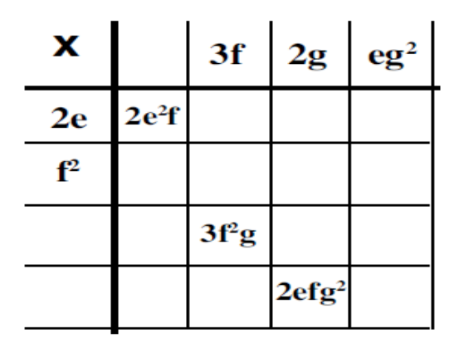  Use the grid method to multiply a 2 digit number by a single digit first eg 23 x 6. Then show how we can also use the grid method to multiply 4(x+5)  x 5  4 4x 20  4x + 20 is the expanded answer  Once secure give some examples like 4(x + 5) + 3x that involve expanding the bracket and then collecting like terms afterwards
Addressing gaps  SEND learners have a Pupil Passport that informs strategies for learning bespoke to that student.  Staff must make sure they are familiar with the various strategies involved and embed these in their lessons.  Use grid method with number before linking it into algebra. Don’t remove the grid with algebra too early. Have copies of ready made grids available. |  | Deepening knowledge  Involve directed number and some simple fractions and decimals eg, 4(x + $\frac{1}{2}$)

Week/ Lesson  Key Question? | Key knowledge components & Lesson Outcomes  What do students need to know & what should they be able to do? | Pedagogy & Assessment– How do we teach and assess this at Coal Clough Academy? Strategies to support students knowing more & remembering more  Suggested teaching activities & resources including ‘non-negotiables’ for delivery e.g. minimum of two assessment style questions per week, minimum of one practical per week…
Week 2/ Lesson 5 | What are the key knowledge components students must be taught this lesson?  - I know how to expand and factorise single and double brackets  - I can expand and factorise single and double brackets  What are the learning outcomes for this lesson?  - Multiplying double brackets and collecting like terms  Key Questions:  How did we multiply out a single bracket?  What is x times x? Is it 2x?  How did we do this when we did negative numbers? | Key vocabulary for this lesson & how it will be introduced ?  Multiply, brackets, collect like terms, quadratic, equation, brackets, indices, powers, grid method  Recall activity: 4 Qs (last lesson, last week, last month, last topic); Use questions from assessments (informal and formal) and QLA.  Suggested teaching activities, pedagogy and assessment to inform next steps:  Start with expansion of a bracket with a single term from pervious lesson eg 4(x + 5) using grid method and then extend to double brackets eg (x+3)(x+ 4)  x +3  x X² 3x  +4 4x +12  Then add up what’s in the grid to get x² + 7x + 12
Addressing gaps  SEND learners have a Pupil Passport that informs strategies for learning bespoke to that student.  Staff must make sure they are familiar with the various strategies involved and embed these in their lessons.  Don’t take the grid away from students too early (have copies of ready made grids available) |  | Deepening knowledge  Use examples with negatives in one bracket and in both brackets  Use examples with different variables and the variables in different positions eg (t -4)(t +6), (6 + t)(5 + t)

Week/ Lesson  Key Question? | Key knowledge components & Lesson Outcomes  What do students need to know & what should they be able to do? | Pedagogy & Assessment– How do we teach and assess this at Coal Clough Academy? Strategies to support students knowing more & remembering more  Suggested teaching activities & resources including ‘non-negotiables’ for delivery e.g. minimum of two assessment style questions per week, minimum of one practical per week…
Week2/ Lesson 6 | What are the key knowledge components students must be taught this lesson?  - I know how to expand and factorise single and double brackets  - I can expand and factorise single and double brackets  What are the learning outcomes for this lesson?  - Multiplying double brackets and collecting like terms  Key Questions:  How did we multiply out a single bracket?  What is x times x? Is it 2x?  How did we do this when we did negative numbers? | Key vocabulary for this lesson & how it will be introduced ?  Multiply, brackets, collect like terms, quadratic, equation, brackets, indices, powers, grid method  Recall activity: 4 Qs (last lesson, last week, last month, last topic); Use questions from assessments (informal and formal) and QLA.  Suggested teaching activities, pedagogy and assessment to inform next steps:  Start with expansion of a bracket with a single term from pervious lesson eg 4(x + 5) using grid method and then extend to double brackets eg (x+3)(x+ 4)  x +3  x X² 3x  +4 4x +12  Then add up what’s in the grid to get x² + 7x + 12  Give lots of examples with negatives eg (x+5)(x-4)
Addressing gaps  SEND learners have a Pupil Passport that informs strategies for learning bespoke to that student.  Staff must make sure they are familiar with the various strategies involved and embed these in their lessons.  Don’t take the grid away from students too early (have copies of ready made grids available) |  | Deepening knowledge  Give some perfect squares eg (x+6)²  Give examples requiring a double bracket to be expanded and then collecting like terms eg (x-3)(x+ 4) + 5x

Week/ Lesson  Key Question? | Key knowledge components & Lesson Outcomes  What do students need to know & what should they be able to do? | Pedagogy & Assessment– How do we teach and assess this at Coal Clough Academy? Strategies to support students knowing more & remembering more  Suggested teaching activities & resources including ‘non-negotiables’ for delivery e.g. minimum of two assessment style questions per week, minimum of one practical per week…
Week 3/ Lesson 7 | What are the key knowledge components students must be taught this lesson?  - I know how to expand and factorise single and double brackets  - I can expand and factorise single and double brackets  What are the learning outcomes for this lesson?  - Factorising where the common factor is a single digit  Key Questions:  What do we mean by factorise? What other maths word can you see in factorise?  What number should replace the question mark ?  ?(x +5) = 4x + 20  How can I check that I have factorized this properly? Eg  9x + 6 = 3(3x + 2)?? | Key vocabulary for this lesson & how it will be introduced?  Factorise, factor, brackets, indices, powers, grid method  Recall activity: 4 Qs (last lesson, last week, last month, last topic); Use questions from assessments (informal and formal) and QLA.  Suggested teaching activities, pedagogy and assessment to inform next steps:  Use some examples of the grid method to multiply where one factor is missing but you have the expanded answer so students can see that factorizing is the inverse of expanding.  x 5  ? 4x 20  What number should replace the question mark ?(x +5) = 4x + 20  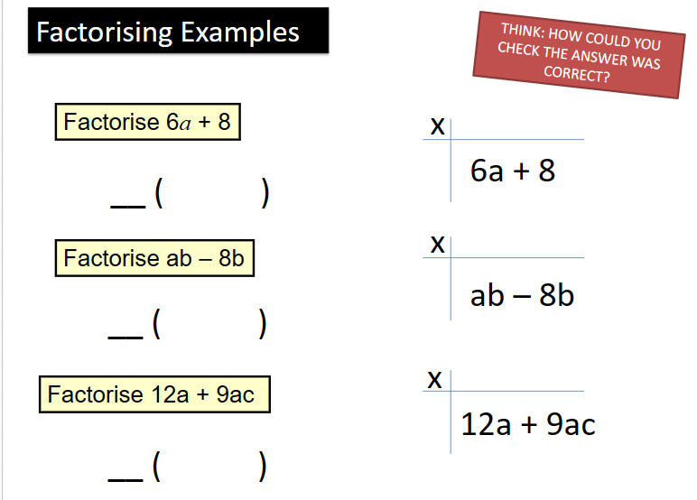  Teach factorising as the inverse of expanding.
Addressing gaps  SEND learners have a Pupil Passport that informs strategies for learning bespoke to that student.  Staff must make sure they are familiar with the various strategies involved and embed these in their lessons.  Use grids for some students so that they can gap fill to factorise and remove the grid once they are secure. |  | Deepening knowledge  Use examples with negative numbers and some simple fractions/decimals

Week/ Lesson  Key Question? | Key knowledge components & Lesson Outcomes  What do students need to know & what should they be able to do? | Pedagogy & Assessment– How do we teach and assess this at Coal Clough Academy? Strategies to support students knowing more & remembering more  Suggested teaching activities & resources including ‘non-negotiables’ for delivery e.g. minimum of two assessment style questions per week, minimum of one practical per week…
Week 3/ Lesson 8 | What are the key knowledge components students must be taught this lesson?  - I know how to expand and factorise single and double brackets  - I can expand and factorise single and double brackets  What are the learning outcomes for this lesson?  - Factorising where the common factor is a single digit  Key Questions:  What do we mean by factorise? What other maths word can you see in factorise?  What number should replace the question mark ?  ?(x +5) = 4x + 20 | Key vocabulary for this lesson & how it will be introduced?  Factorise, factor  Recall activity: 4 Qs (last lesson, last week, last month, last topic); Use questions from assessments (informal and formal) and QLA.  Suggested teaching activities, pedagogy and assessment to inform next steps:  Use some examples of the grid method to multiply where one factor is missing but you have the expanded answer  x 5  ? 4x 20  What number should replace the question mark ?(x +5) = 4x + 20    Teach factorising as the opposite of expanding
Addressing gaps  SEND learners have a Pupil Passport that informs strategies for learning bespoke to that student.  Staff must make sure they are familiar with the various strategies involved and embed these in their lessons.  Use grids for some students so that they can gap fill to factorise and remove the grid once they are secure. |  | Deepening knowledge  Use examples with negative numbers and some simple fractions/decimals

Week/ Lesson  Key Question? | Key knowledge components & Lesson Outcomes  What do students need to know & what should they be able to do? | Pedagogy & Assessment– How do we teach and assess this at Coal Clough Academy? Strategies to support students knowing more & remembering more  Suggested teaching activities & resources including ‘non-negotiables’ for delivery e.g. minimum of two assessment style questions per week, minimum of one practical per week…
Week 3/ Lesson 9 | What are the key knowledge components students must be taught this lesson?  - I know mathematical conventions for solving equations containing fractions, brackets and variables on both sides.  - I can solve equations containing fractions, brackets and variables on both sides.  What are the learning outcomes for this lesson?  - Solving linear equations using inverses  Key Questions:  What steps do I need to take to solve this?  What should I do first? Why?  If I have a scale and I take 3 off one side what will happen to the scale? How can I make it balance again? | Key vocabulary for this lesson & how it will be introduced?  Solve, evaluate, calculate, inverse, simplify, expand, factorise, collect like terms  Recall activity: 4 Qs (last lesson, last week, last month, last topic); Use questions from assessments (informal and formal) and QLA.  Suggested teaching activities, pedagogy and assessment to inform next steps:  Avoid using a for apples and b for bananas in your vocabulary so that students understand a ≠ 1 apple. Use ‘the number of’ in your language eg a = a number of apples.  Students confuse x² with 2x  Be specific with mathematical algebraic conventions eg 2t means 2 x t  Be specific with language such as the difference between an expression and an equation  Use scales to show how to keep it equal whatever you do to one side you need to do to the other. 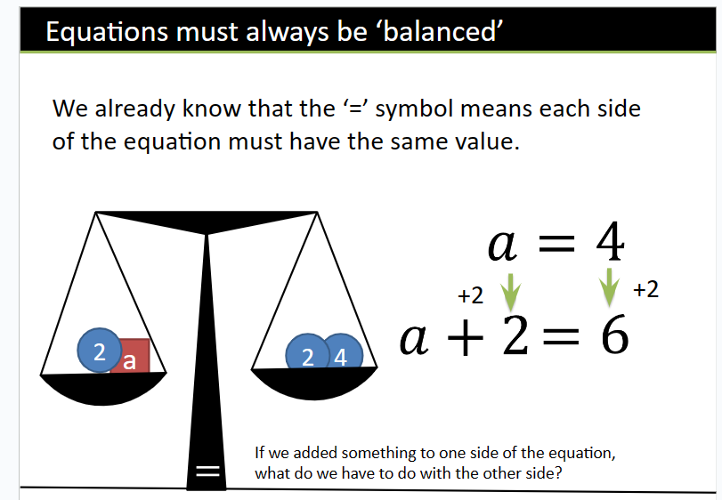
Addressing gaps  SEND learners have a Pupil Passport that informs strategies for learning bespoke to that student.  Staff must make sure they are familiar with the various strategies involved and embed these in their lessons.  Use function machine grids with students who need them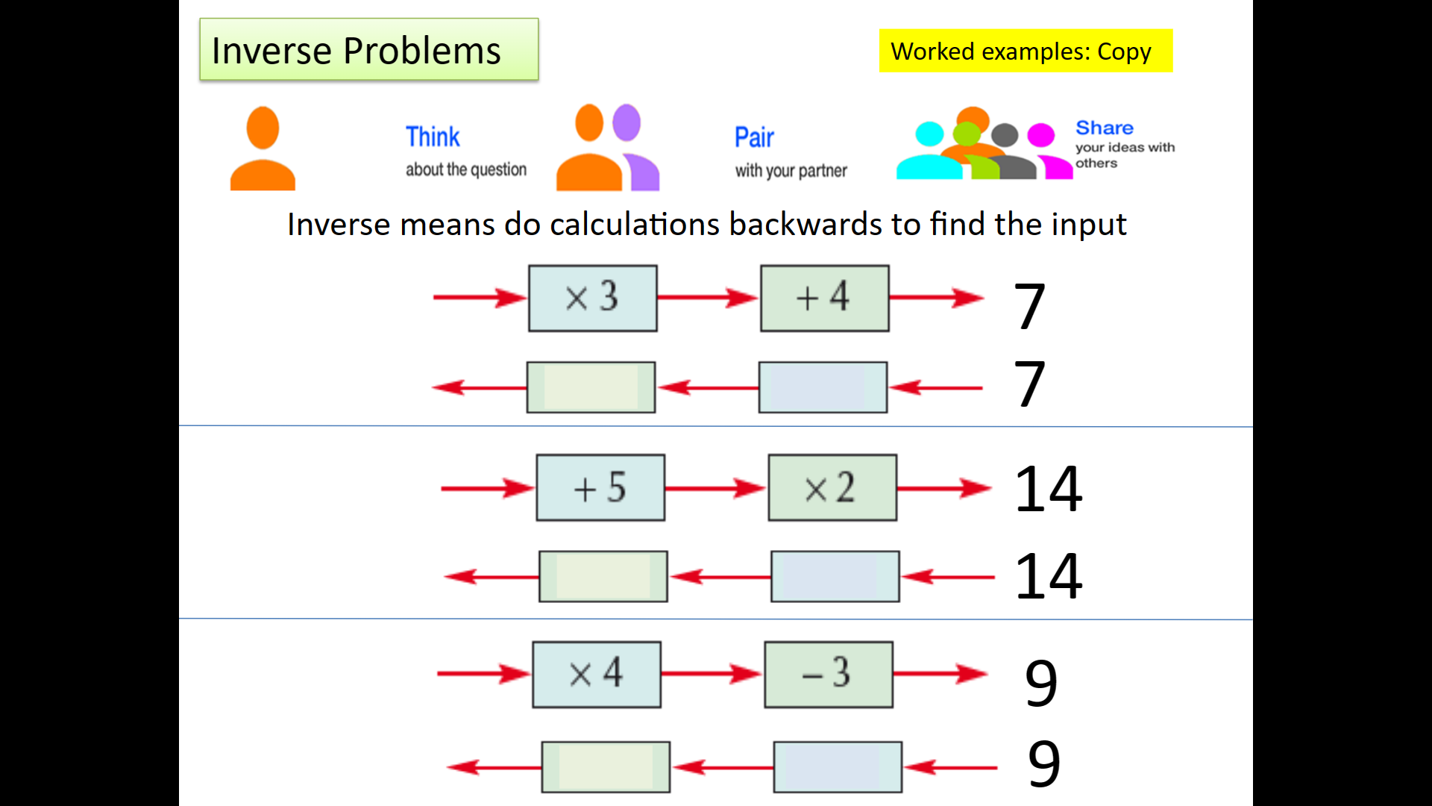 |  | Deepening knowledge  Use lots of negatives and simple fractions
Week/ Lesson  Key Question? | Key knowledge components & Lesson Outcomes  What do students need to know & what should they be able to do? | Pedagogy & Assessment– How do we teach and assess this at Coal Clough Academy? Strategies to support students knowing more & remembering more  Suggested teaching activities & resources including ‘non-negotiables’ for delivery e.g. minimum of two assessment style questions per week, minimum of one practical per week…
Week 4/ Lesson 10 | What are the key knowledge components students must be taught this lesson?  - I know mathematical conventions for solving equations containing fractions, brackets and variables on both sides.  - I can solve equations containing fractions, brackets and variables on both sides.  What are the learning outcomes for this lesson?  - Solving linear equations using inverses (including where bracket expansion is necessary first)  Key Questions:  What steps do I need to take to solve this?  What should I do first? Why?  Remember our scale – if I multiply this side by 3, what do I need to do to the other side? | Key vocabulary for this lesson & how it will be introduced?  Solve, evaluate, calculate, inverse, simplify, expand, factorise, collect like terms  Recall activity: 4 Qs (last lesson, last week, last month, last topic); Use questions from assessments (informal and formal) and QLA.  Suggested teaching activities, pedagogy and assessment to inform next steps:  Avoid using a for apples and b for bananas in your vocabulary so that students understand a ≠ 1 apple. Use ‘the number of’ in your language eg a = a number of apples.  Students confuse x² with 2x  Be specific with mathematical algebraic conventions eg 2t means 2 x t  Be specific with language such as the difference between an expression and an equation
Addressing gaps  SEND learners have a Pupil Passport that informs strategies for learning bespoke to that student.  Staff must make sure they are familiar with the various strategies involved and embed these in their lessons. |  | Deepening knowledge  Use lots of negatives and simple fractions

Week/ Lesson  Key Question? | Key knowledge components & Lesson Outcomes  What do students need to know & what should they be able to do? | Pedagogy & Assessment– How do we teach and assess this at Coal Clough Academy? Strategies to support students knowing more & remembering more  Suggested teaching activities & resources including ‘non-negotiables’ for delivery e.g. minimum of two assessment style questions per week, minimum of one practical per week…
Week 4/ Lesson 11 | What are the key knowledge components students must be taught this lesson?  - I know mathematical conventions for solving equations containing fractions, brackets and variables on both sides.  - I can solve equations containing fractions, brackets and variables on both sides.  What are the learning outcomes for this lesson?  - Solving linear equations with variables on both sides  Key Questions:  What do I do when I have variables on both sides?  How do I get the variables on one side?  What steps do I need to take to solve this? | Key vocabulary for this lesson & how it will be introduced?  Recall activity: 4 Qs (last lesson, last week, last month, last topic); Use questions from assessments (informal and formal) and QLA.  Suggested teaching activities, pedagogy and assessment to inform next steps:  Avoid using a for apples and b for bananas in your vocabulary so that students understand a ≠ 1 apple. Use ‘the number of’ in your language eg a = a number of apples.  Students confuse x² with 2x  Be specific with mathematical algebraic conventions eg 2t means 2 x t  Be specific with language such as the difference between an expression and an equation  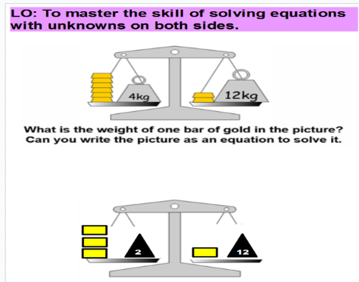  Use the same balancing technique with variables on both sides:
Addressing gaps  SEND learners have a Pupil Passport that informs strategies for learning bespoke to that student.  Staff must make sure they are familiar with the various strategies involved and embed these in their lessons. |  | Deepening knowledge  Use lots of negatives and simple fractions.

Week/ Lesson  Key Question? | Key knowledge components & Lesson Outcomes  What do students need to know & what should they be able to do? | Pedagogy & Assessment– How do we teach and assess this at Coal Clough Academy? Strategies to support students knowing more & remembering more  Suggested teaching activities & resources including ‘non-negotiables’ for delivery e.g. minimum of two assessment style questions per week, minimum of one practical per week…
Week 4/ Lesson 12 | What are the key knowledge components students must be taught this lesson?  - I know mathematical conventions for solving equations containing fractions, brackets and variables on both sides.  - I can solve equations containing fractions, brackets and variables on both sides.  What are the learning outcomes for this lesson?  - Solving linear equations with variables on both sides  Key Questions:  What do I do when I have variables on both sides?  How do I get the variables on one side?  What steps do I need to take to solve this? | Key vocabulary for this lesson & how it will be introduced?  Recall activity: 4 Qs (last lesson, last week, last month, last topic); Use questions from assessments (informal and formal) and QLA.  Suggested teaching activities, pedagogy and assessment to inform next steps:  Avoid using a for apples and b for bananas in your vocabulary so that students understand a ≠ 1 apple. Use ‘the number of’ in your language eg a = a number of apples.  Students confuse x² with 2x  Be specific with mathematical algebraic conventions eg 2t means 2 x t  Be specific with language such as the difference between an expression and an equation  Use the same balancing technique with variables on both sides:  
Addressing gaps  SEND learners have a Pupil Passport that informs strategies for learning bespoke to that student.  Staff must make sure they are familiar with the various strategies involved and embed these in their lessons. |  | Deepening knowledge  Use lots of negatives and simple fractions

Week/ Lesson  Key Question? | Key knowledge components & Lesson Outcomes  What do students need to know & what should they be able to do? | Pedagogy & Assessment– How do we teach and assess this at Coal Clough Academy? Strategies to support students knowing more & remembering more  Suggested teaching activities & resources including ‘non-negotiables’ for delivery e.g. minimum of two assessment style questions per week, minimum of one practical per week…
Week 6/ Lesson 16 | What are the key knowledge components students must be taught this lesson?  - I can form formulas, substitute values into formulas and rearrange formulas to make another letter the subject.  What are the learning outcomes for this lesson?  - Write formulas from a problem, substitute values into formulas to find answers  Key Questions:  Guide students towards forming formulas and equations by highlighting parts of a question eg I think of a number – what variable could I give that number?  I multiply my number by 4 – how would I write that? | Key vocabulary for this lesson & how it will be introduced?  Recall activity: 4 Qs (last lesson, last week, last month, last topic); Use questions from assessments (informal and formal) and QLA.  Suggested teaching activities, pedagogy and assessment to inform next steps:  Start with worded problems for students to solve as a puzzle eg  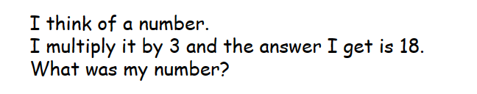  Link into other areas of maths such as perimeter, area and angle facts that students have been taught, eg.,  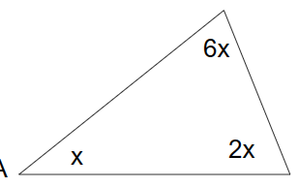  Get students to rearrange formulas that they are familiar with form maths or science eg.,  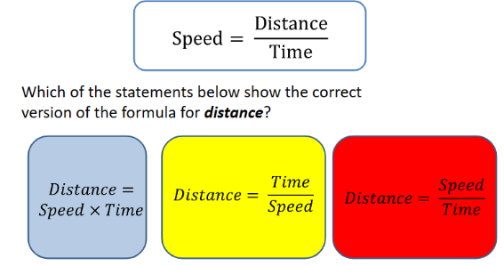
Addressing gaps  SEND learners have a Pupil Passport that informs strategies for learning bespoke to that student.  Staff must make sure they are familiar with the various strategies involved and embed these in their lessons. |  | Deepening knowledge  Link formulating and solving or re-arranging formulas into other parts of math seg.,  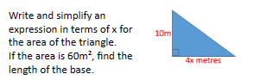

Week/ Lesson  Key Question? | Key knowledge components & Lesson Outcomes  What do students need to know & what should they be able to do? | Pedagogy & Assessment– How do we teach and assess this at Coal Clough Academy? Strategies to support students knowing more & remembering more  Suggested teaching activities & resources including ‘non-negotiables’ for delivery e.g. minimum of two assessment style questions per week, minimum of one practical per week…
Week 6/ Lesson 17 | What are the key knowledge components students must be taught this lesson?  - I can form formulas, substitute values into formulas and rearrange formulas to make another letter the subject.  What are the learning outcomes for this lesson?  - Rearrange formulas to make another letter the subject.  Key Questions:  At the moment y is the subject. I want to end out with g as the subject so what do I need to do first?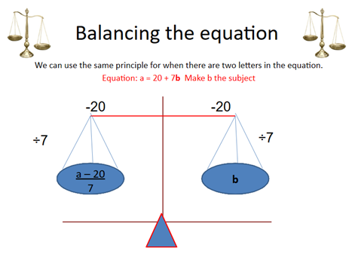  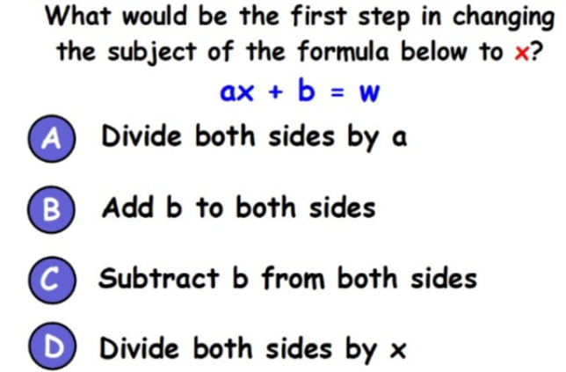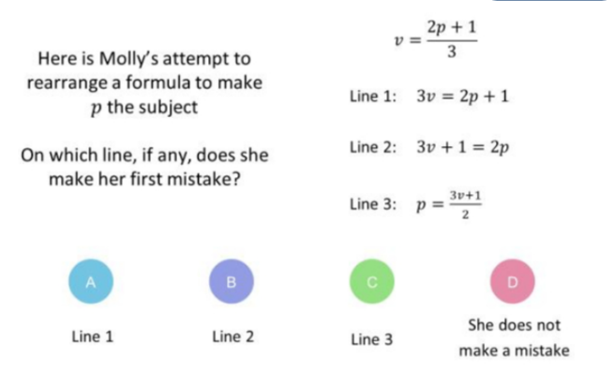 | Key vocabulary for this lesson & how it will be introduced?  Rearrange, subject, inverse  Recall activity: 4 Qs (last lesson, last week, last month, last topic); Use questions from assessments (informal and formal) and QLA.  Suggested teaching activities, pedagogy and assessment to inform next steps:  Link in with balancing scales eg.,  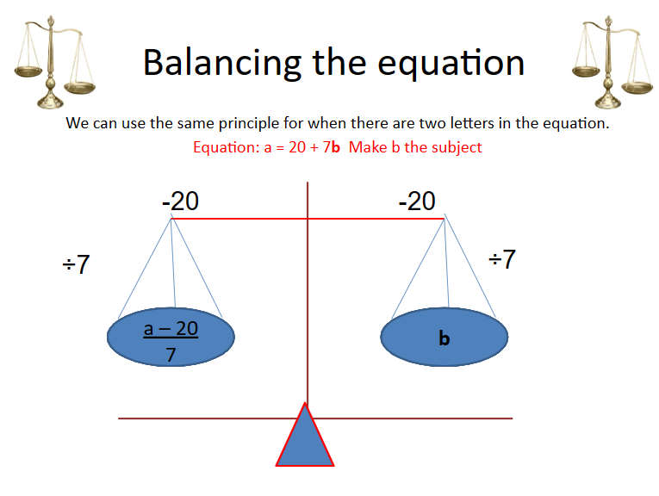  Start with 1 step rearranging before moving to 2 step eg  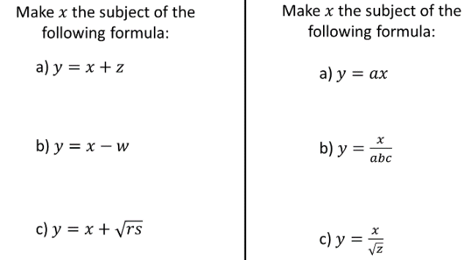
Addressing gaps  SEND learners have a Pupil Passport that informs strategies for learning bespoke to that student.  Staff must make sure they are familiar with the various strategies involved and embed these in their lessons. |  | Deepening knowledge  Use formulas involving more complex operations like roots and multi step operations to rearrange.

Week/ Lesson  Key Question? | Key knowledge components & Lesson Outcomes  What do students need to know & what should they be able to do? | Pedagogy & Assessment– How do we teach and assess this at Coal Clough Academy? Strategies to support students knowing more & remembering more  Suggested teaching activities & resources including ‘non-negotiables’ for delivery e.g. minimum of two assessment style questions per week, minimum of one practical per week…
Week 6/ Lesson 18 | What are the key knowledge components students must be taught this lesson?  - I can form formulas, substitute values into formulas and rearrange formulas to make another letter the subject.  What are the learning outcomes for this lesson?  - Rearrange formulas to make another letter the subject.  Key Questions:  See lesson 17 | Key vocabulary for this lesson & how it will be introduced?  Rearrange, subject, inverse  Recall activity: 4 Qs (last lesson, last week, last month, last topic); Use questions from assessments (informal and formal) and QLA.  Suggested teaching activities, pedagogy and assessment to inform next steps:  See lesson 17
Addressing gaps  SEND learners have a Pupil Passport that informs strategies for learning bespoke to that student.  Staff must make sure they are familiar with the various strategies involved and embed these in their lessons. |  | Deepening knowledge  Use formulas involving more complex operations like roots and multi step operations to rearrange.

Week/ Lesson  Key Question? | Key knowledge components & Lesson Outcomes  What do students need to know & what should they be able to do? | Pedagogy & Assessment– How do we teach and assess this at Coal Clough Academy? Strategies to support students knowing more & remembering more  Suggested teaching activities & resources including ‘non-negotiables’ for delivery e.g. minimum of two assessment style questions per week, minimum of one practical per week…
Week 7/ Lesson 19 | What are the key knowledge components students must be taught this lesson?  - I know how to find a position to term rule (nth term) to find terms and positions in a sequence.  - I can use a position to term rule (nth term) to find terms and positions in a sequence.  What are the learning outcomes for this lesson?  - Finding position to term rules  - Writing position to term rules algebraically  - Using position to term rules to predict the nth term  Key Questions:  What is the 100th term? What is the 1000th term? Why is the term to term rule limited?  What are you doing to the variable first? What are you doing second?  How can I write this algebraically?  What is the sequence going up/down in each time?  What would the 0th term be? Or what would the term before the first term be? | Key vocabulary for this lesson & how it will be introduced?  Pattern, generalise, predict, substitute, inverse, term, sequence  Recall activity: 4 Qs (last lesson, last week, last month, last topic); Use questions from assessments (informal and formal) and QLA.  Suggested teaching activities, pedagogy and assessment to inform next steps:  Starter: start calling out a sequence and have a competition to see who can predict the next term and the term to term rule first – use more difficult example than last lesson  Get students to write their own sequences and then swap with a partner to find the next term and the term to term rule.  Avoid using a for apples and b for bananas in your vocabulary so that students understand a ≠ 1 apple. Use ‘the number of’ in your language eg a = a number of apples.  Students confuse x² with 2x  Be specific with mathematical algebraic conventions eg 2t means 2 x t  Be specific with language such as the difference between an expression and an equation.  Generalise to help students find the nth term of any linear sequences eg.,  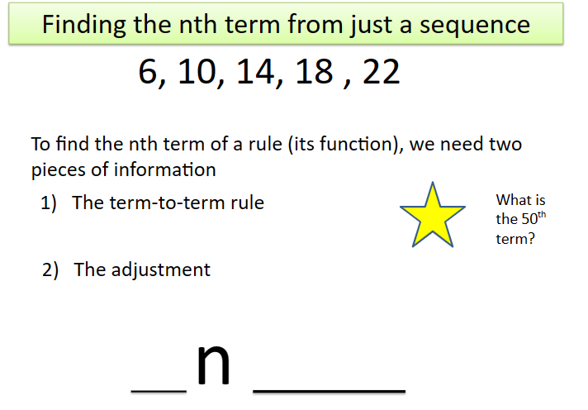  Use decreasing sequences as well  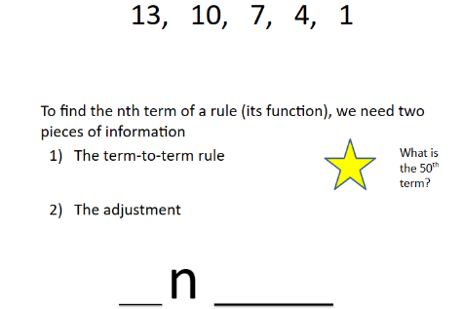
Addressing gaps  SEND learners have a Pupil Passport that informs strategies for learning bespoke to that student.  Staff must make sure they are familiar with the various strategies involved and embed these in their lessons.  Use function machines to support and give students blank function machines to use as they wish. |  | Deepening knowledge  Use sequences increasing/decreasing by a decimal/fraction  Use sequences involving directed number

Week/ Lesson  Key Question? | Key knowledge components & Lesson Outcomes  What do students need to know & what should they be able to do? | Pedagogy & Assessment– How do we teach and assess this at Coal Clough Academy? Strategies to support students knowing more & remembering more  Suggested teaching activities & resources including ‘non-negotiables’ for delivery e.g. minimum of two assessment style questions per week, minimum of one practical per week…
Week 7/ Lesson 20 | What are the key knowledge components students must be taught this lesson?  - I know how to find the nth term rule for a sequence.  - I can find the nth term rule for a sequence.  What are the learning outcomes for this lesson?  - Forming 1 and 2 step linear equations to solve linear sequences;  - Substituting into linear sequences to find the nth term  Key Questions:  What’s the first step? And the next? How would I write that sentence algebraically? | Key vocabulary for this lesson & how it will be introduced?  Pattern, generalise, predict, substitute, inverse, term, sequence,  Recall activity: 4 Qs (last lesson, last week, last month, last topic); Use questions from assessments (informal and formal) and QLA.  Suggested teaching activities, pedagogy and assessment to inform next steps:  Avoid using a for apples and b for bananas in your vocabulary so that students understand a ≠ 1 apple. Use ‘the number of’ in your language eg a = a number of apples.  Students confuse x² with 2x  Be specific with mathematical algebraic conventions eg 2t means 2 x t  Be specific with language such as the difference between an expression and an equation
Addressing gaps  SEND learners have a Pupil Passport that informs strategies for learning bespoke to that student.  Staff must make sure they are familiar with the various strategies involved and embed these in their lessons.  Use practical, visual examples where students struggle to visualize the algebra |  | Deepening knowledge  Use sequences increasing/decreasing by a decimal/fraction  Use sequences involving directed number

Week/ Lesson  Key Question? | Key knowledge components & Lesson Outcomes  What do students need to know & what should they be able to do? | Pedagogy & Assessment– How do we teach and assess this at Coal Clough Academy? Strategies to support students knowing more & remembering more  Suggested teaching activities & resources including ‘non-negotiables’ for delivery e.g. minimum of two assessment style questions per week, minimum of one practical per week…
Week 7/ Lesson 21 | What are the key knowledge components students must be taught this lesson?  - I can read a worded question and from it form a mathematical equation.  What are the learning outcomes for this lesson?  - Generalising the formula for arithmetic sequences  Key Questions:  How many matches would be in the next term?  What would the position to term rule be?  How many matches would there be in the 1000th term?  Which term would use more than 100 matches? | Key vocabulary for this lesson & how it will be introduced?  Generalize, term, pattern, predict, substitute, inverse, , sequence,  Recall activity: 4 Qs (last lesson, last week, last month, last topic); Use questions from assessments (informal and formal) and QLA.  Suggested teaching activities, pedagogy and assessment to inform next steps:  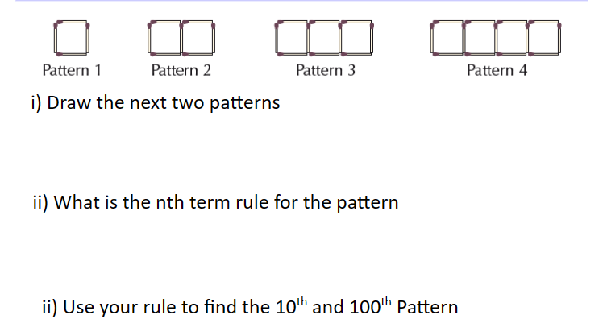  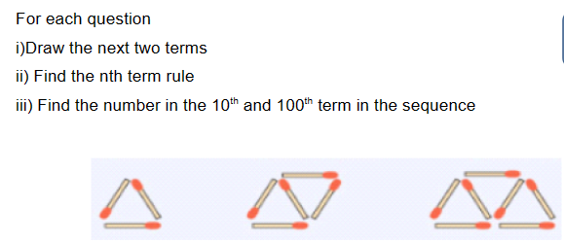
Addressing gaps  SEND learners have a Pupil Passport that informs strategies for learning bespoke to that student.  Staff must make sure they are familiar with the various strategies involved and embed these in their lessons. |  | Deepening knowledge

